Project Report Format

# INTRODUCTION

* 1. Project Overview:

Smart Sorting is a transfer-learning -powered web application that classifies fruits and vegetables as Healthy or Rotten using Transfer Learning (VGG16). It helps reduce food waste and enhance quality control in households, markets, and supply chains.

* 1. Purpose:

To automate the sorting process of produce, ensuring faster and more accurate identification of items that are unfit for consumption.

# IDEATION PHASE

* 1. Problem Statement;

Manual sorting is prone to human error and inconsistency, leading to food waste, quality loss, and inefficiency in produce distribution.

* 1. Empathy Map Canvas:

**👤 User Persona:**  
Produce quality checker in a supermarket / Vendor at a local market

**🗣️ Says**

* “I can’t always tell which items are still fresh.”
* “I wish there was a faster, more reliable way to sort produce.”
* “I don’t want to throw away good fruits by mistake.”
  1. Brainstorming

-Use VGG16 for transfer learning

-Web interface for uploads and predictions

-Display confidence and feedback

# REQUIREMENT ANALYSIS

* 1. Customer Journey map
  2. Solution Requirement
  3. Data Flow Diagram
  4. Technology Stack

# PROJECT DESIGN

* 1. Problem Solution Fit
  2. Proposed Solution
  3. Solution Architecture

# PROJECT PLANNING & SCHEDULING

* 1. Project Planning

# FUNCTIONAL AND PERFORMANCE TESTING

* 1. Performance Testing

# RESULTS

* 1. Output Screenshots

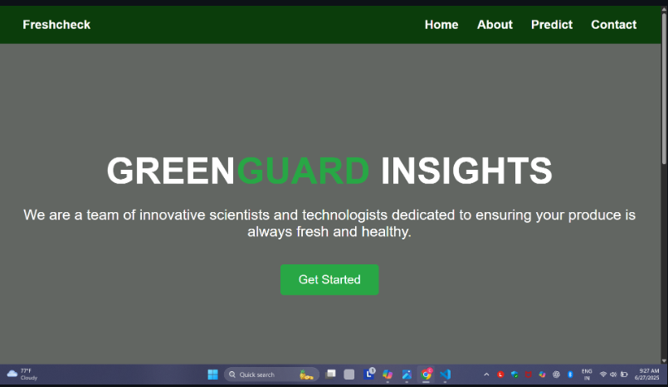

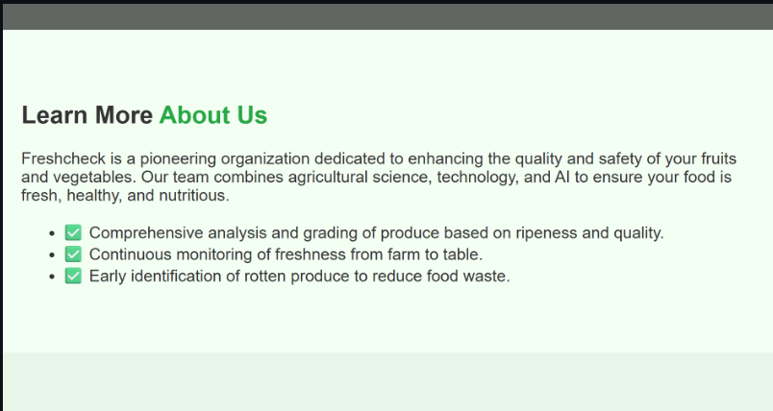

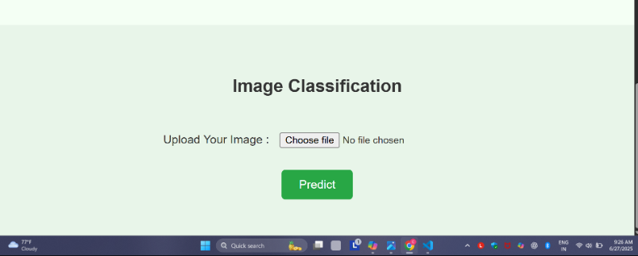

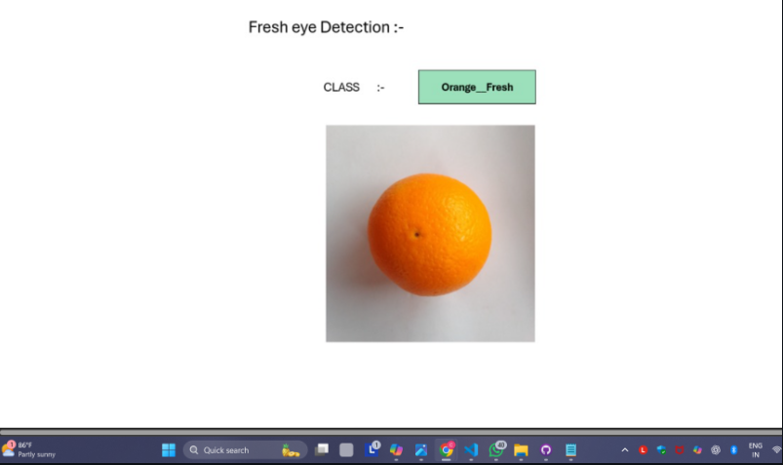

1. **ADVANTAGES & DISADVANTAGES**

|  |  |
| --- | --- |
| **Advantages** | **Disadvantages** |
| **Reduces food waste** | **Limited to image quality** |
| **Enhances decision-making** | **Depends on dataset diversity** |
| **Easy to use for all audiences** | **Needs stable internet for predictions** |
| **Fast and accurate predictions** | **Not a replacement for expert inspection in critical use cases** |
| **Portable web-based solution** | **Not a complete replacement for experts** |

1. **CONCLUSION**

Smart Sorting Shows how deep learning and web deployment can simplify a real-World challenge, with meaningful social and commercial impact

1. **FUTURE SCOPE**

* Mobile and camera input support
* Expand category classes

1. **APPENDIX**
   1. Dataset Link

[**https://www.kaggle.com/datasets/muhammad0subhan/fruit-and-vegetable-disease-healthy-vs-rotten**](https://www.kaggle.com/datasets/muhammad0subhan/fruit-and-vegetable-disease-healthy-vs-rotten)

* 1. GitHub & Project Demo Link
     + GitHub Link

https://github.com/chandana-0/smart-sorting-transfer-learning-for-identifying-rotten-fruits-and-vegetables